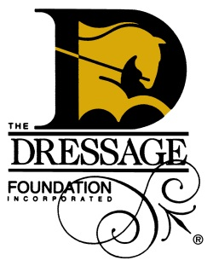

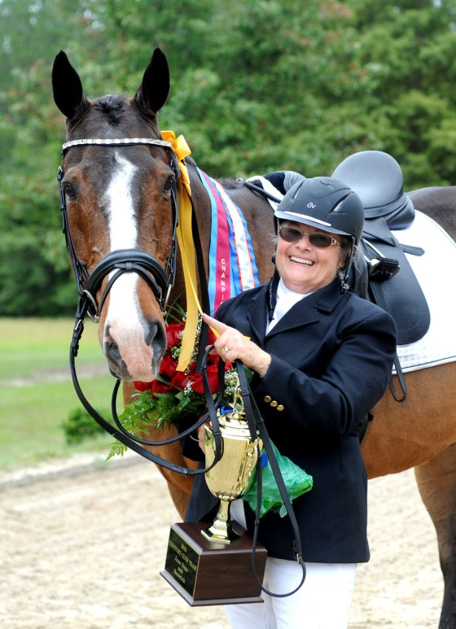
Honor the Seniors of Dressage…
Support TDF’s Century Club!

We are so happy to be the home of the Century Club and love to provide a little time in the spotlight for the seniors of our sport.

To join TDF’s Century Club, the combined ages of the horse and rider must equal 100 or more years. The Century Club members are so important; they encourage us to continue riding as we age, they teach us about the importance of fitness for our senior horses, they inspire equestrians across disciplines and across the country.

Since 1996, The Dressage Foundation has proudly supported the Century Club by giving each new team a commemorative plaque and also, in more recent years, a Century Club ribbon. In the past few years, the Century Club has experienced dramatic growth and we expect the same for 2016 and beyond.
Jane Sage, age 76 and Keswick, age 24
Team #219

Since the increased popularity of the Century Club also means increased costs to TDF, we have come to a time when we are in need of some financial help in order to continue this program. We are asking you, our GMO friends, to consider supporting the Century Club this year.

Your sponsorship of $100 or more ensures that another senior horse and rider team will be recognized for their accomplishment by providing the necessary funds for a plaque, ribbon, and the production of our annual Century Club newsletter.

I can be reached at (402) 434-8585 or jenny@dressagefoundation.org if you have any questions. I hope that you will help us honor our senior friends!

Cordially,

Jenny Johnson
Executive Director
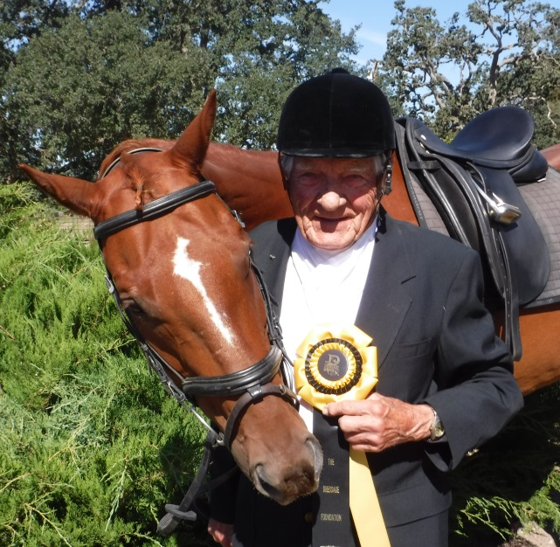
How you can help:
1314 ‘O’ Street, Suite 305, Lincoln, NE 68508
(402) 434-8585
info@dressagefoundation.org

- A donation of $100 or more will enable us to give a Century Club plaque and ribbon to one new team. Additionally, your contribution will help us produce the annual Century Club newsletter, which is mailed to all members, past and present.

- Your contribution can be made at any time. Please complete the form below and mail to The Dressage Foundation or visit www.dressagefoundation.org to donate online.

- For your donation of $100 or more, you will receive regular updates about our Century Club and your sponsorship will be recognized on The Dressage Foundation’s website and in the Century Club News. A copy of the next Century Club News, featuring all teams from 2016, will be mailed to you in January or February 2017.
Eldon Kordes, age 90 and Ben, age 15
Team #212
- Most importantly, you’ll be helping us to honor the seniors of our sport who provide so much encouragement and inspiration to us all!

To learn more about the Century Club, visit www.dressagefoundation.org or contact
Jenny Johnson at (402) 434-8585 or jenny@dressagefoundation.org.

__________________________________________________________________________________
Yes, we would like to support the Century Club in 2017!
Contact Person:
GMO Name (if applicable):
Contact Person’s Position in GMO (if applicable):
Address:
City, ST, Zip:
Phone:
Email:

Please make checks payable to The Dressage Foundation and mail to:
1314 ‘O’ Street, Suite 305, Lincoln, NE 68508
Or visit www.dressagefoundation.org and click on “Support” to make an online donation.
Thank You!

