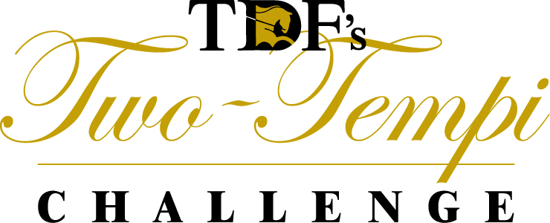
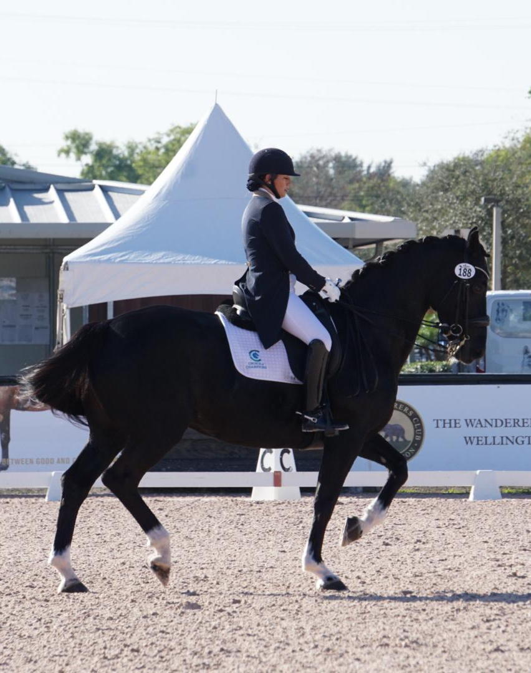
Mel Montagano and GaDeva

2018 TWO-TEMPI CHALLENGE RESULTS
71 total two-tempis performed
$2,887 raised to support TDF

CURRENT NATIONAL CHAMPION
Mel Montagano and GaDeva
Region 3, Florida
37 two-tempis
Global Dressage Festival

CURRENT RESERVE CHAMPION
Ali Perkins and Sante’
Region 8, Maine
20 two-tempis
Global Dressage Festival
REGIONAL RESULTS
CURRENT REGION 3 CHAMPION
Mel Montagano and GaDeva
Florida, 37 two-tempis
Global Dressage Festival
CURRENT REGION 8 CHAMPION
Ali Perkins and Sante’
Maine, 20 two-tempis
CURRENT REGION 8 RESERVE
Hannah Irons and My Lucky Charm
Maryland, 14 two-tempis

DONOR RESULTS
ALI PERKINS
$1,192 RAISED
Anonymous Cash Donors
Facebook Fundraiser Donors
Paul Bird
Roxanne Bok
Roberta Carleton
Kate Davern
Alexa Derr
Jennifer Keller
Tonya and Jack LaTorre
Beth Nicholson
Nancy Perkins
Brenda Roth
Holly Rutland
HANNAH IRONS
$995 RAISED
Donnie and Angela Brady
Andrea Brock
Jenny Carol
Julie Count
Debbie DelGiorno
Harriett Hassle
Michelle Heitman
Darby Hewes
Claire Hodges
David Irons
Susan Jacobs
Michelle King
Jennifer Koch
Lynda LeCrone
Mary McConnell
Lara Osborne
Mona Ridgway
Carol Spicknall
Katherine Walmer
Holly Zickler
MEL MONTAGANO
$605 RAISED
Debbie DelGiorno
Paula Popilock
Helen Vandervoort

