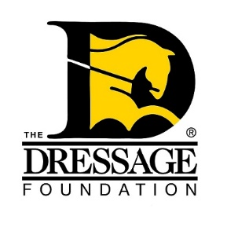
The Dressage Foundation’s

Lynn Palm Western Dressage Fund

Grant Application

You can use this form to gather and save your answers, but the online application found on our website must be completed and received by TDF’s office at least 90 days prior to your event for your application to be considered. Please contact us at (402) 434-8585 or info@dressagefoundation.org if you have questions.

Name:
Organization/Facility Name:
Position held in Organization:
Street Address:
City, State, Zip:
Phone:
Email:

Instructional Program

Tell us about Western Dressage in your area.

Describe your event. Is this a camp, clinic, seminar, symposium?

Be specific and give a description of the program listed above (tentative schedule, list of activities, etc). At least one lecture on basic dressage theory should be included.

How will this event help the participants?

If applicable, list the level of riders who will be participating in this program (do not include auditors).

Event Details

Date of event:

How many riders will attend?
How many auditors will attend?

Fee per rider:
Fee per auditor:

Location - name of facility, type of facility:

Does the facility have a standard dressage arena?

Instructor

Instructor’s name and qualifications

Please provide a YouTube link of a short video (appx 10-20 minutes) of the instructor giving a lesson to a Western Dressage rider of any level.

Sound System
The success of your program can often be compromised by a poor sound system. What type of sound system will you be using for your event?
Has this sound system ever been successfully used for this type of event?

Other

How will you advertise this event?

If your group is awarded a grant from The Dressage Foundation, how will you promote that TDF’s Lynn Palm Western Dressage Fund is a supporter of this program?

Other information regarding your clinic that you think the Selection Committee will find useful in reviewing this application.

Financials

What financial help will your club/facility give to this event?

Include a budget of expenses and income.

Amount requested from The Dressage Foundation:

IMPORTANT NOTES:
The Dressage Foundation's Lynn Palm Western Dressage Fund will grant funding only once in each calendar year per organization/recipient. The maximum grant is $2,000.

Grant funds should only be used to support the educational part of the program and should not be used to purchase food, goodie bags, vests/t-shirts, etc.

Grants from the Lynn Palm Western Dressage Fund may not be used for the organizing group to make a profit and will only be provided to the break-even point for selected events. Excess income should be returned to The Dressage Foundation, to be put back into the Fund.

The complete application and all required attachments must be submitted through the online application form at www.dressagefoundation.org, at least 90 days prior to the start of the event. You will be notified that the application has been received within 2 business days.

If you do not receive email confirmation that your application has been received, please call our office at (402) 434-8585. Additionally, if you have any questions regarding the application, feel free to contact us. Thank you!

