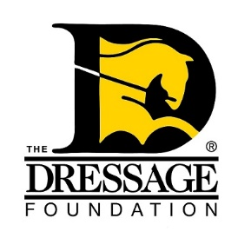
The Dressage Foundation’s Lloyd Landkamer
Show Management Development Fund
Grant Application

Applications will only be accepted through the online form. The following application form and all required attachments must be received by The Dressage Foundation's office on or before March 1st to be considered. Attachments must be in Word, Excel, or PDF format.
We encourage you to review this application and gather all materials prior to starting the online application process. Once you start, your work cannot be saved. Helpful tip - Type your answers into this Word document, save, and then copy and paste your answers into this form.

Applicant Information:
Name
Address
Phone Number
Email Address
Are you a U.S. Citizen or Permanent Resident?
Please list any equestrian organization in which you are a member (local, national, international):
Training Plan or Event (In one sentence)
Proposed Training or Event Dates

General Information:

Provide a brief history of your experience as a show manager, show secretary, or both. Include the types of shows you primarily work at (schooling show/recognized show), your level of management, and the training you have received as a manager/secretary. (Max 250 words)
What are your goals as a show manager and/or show secretary? (Max 100 words)
Proposed Training/Educational Event:
How do you plan to use the grant? Include dates, locations, instructors and their credentials, etc. Training funded by this grant can start no sooner than two months after the application deadline date. (Max 250 words)
With this training plan, what do you specifically want to achieve and what are your plans to achieve those goals? (Max 100 words)
Community Involvement:
In what ways have you been involved in your local dressage community? Examples include hosting open clinics, donating time/resources, volunteer work, etc. (Max 100 words)

Financial Information:
Provide a detailed budget of how you plan to use the $1,000 grant.
What current and past financial assistance/sponsorship have you received, including grants or awards from The Dressage Foundation?

Letter of Recommendation:

Attach one recommendation letter. The letter should speak to your abilities as a manager and/or secretary and your desire to continue your education.

Signature Page:

Download and sign where indicated on the Signature Page.

Important notes:

You will be notified that the application has been received within two business days. If you do not receive email confirmation (please check your spam folder!) that your application has been received, call our office at (402) 434-8585. Additionally, if you have any questions regarding the application, feel free to contact us. After the grant selection committee has made its final decision, all applicants will be notified. Thank you!

