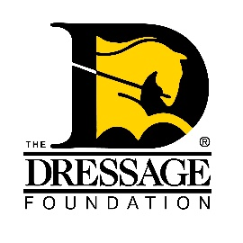
The Dressage Foundation’s
Military Grant Fund

Grant Application

You can use this form to gather and save your answers, but the online application found on our website must be completed and received by TDF’s office on or before May 15th for your application to be considered. Please contact us at (402) 434-8585 or info@dressagefoundation.org if you have questions or need assistance.

General Information

Name:
Address:
Phone:
Email:
Are you a U.S. Citizen or Permanent Resident? Yes/No
Parent/Guardian name, phone, email (if applicant under the age of 19):

Are you applying as a youth, adult amateur, and/or as a para-equestrian dressage rider?

If applying as an amateur, please confirm the following:
I understand that it is my responsibility to know the rules governing amateur status. I certify that I am an amateur within the meaning of USEF Article GR 1306.
Please list equestrian organizations in which you are a member (including local clubs).

What amount are you requesting from the Military Grant Fund? Grants are typically $1,000.

Proposed Training (in one sentence):

You will provide additional details below.
Proposed Training Dates:

Riding/Training Information

Provide a brief summary of your dressage experience, including levels ridden, awards received, and key educational activities attended in the past few years. Please include any volunteer experiences you may have. (250 words maximum)

What are your goals as a rider?

Describe the training you would like to receive with this Grant. Include instructor’s name, credentials, and a few sentences about why you want to work with this instructor.

What would this Grant allow you to do that you would be unable to do otherwise?

Military Information

How are you associated with the military? If you are current or retired military, what was your rank and years of service? If you are a dependent, please describe your parent/guardian rank and years of service.

How has being a part of the military community impacted you as a dressage rider? (250 words maximum)

Financial Information

Provide a budget of anticipated expenses for your stated training plan. (Expenses can include training, trailering, horse board, hotel, food, etc that are directly related to your training plan. Keep in mind, these grants are not intended for competition.)

Financially speaking, why do you need this grant for your dressage training?

Recommendation Letters

Provide two letters of recommendation – At least one must be from individuals within the dressage/equestrian industry who can reflect on you as a horseperson, such as an instructor/trainer, judge, GMO leader, or barn owner.

Signature Page

Download and sign where indicated on the Signature Page.

