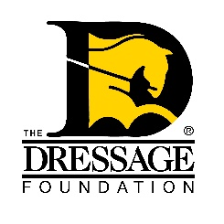**The Dressage Foundation’s**

***Century Club Application***

*Please return completed applications at least* ***two weeks*** *prior to the*

*date of the scheduled ride to ensure your ribbon arrives in time****.***

€ Check here if this is your first Century Club ride. If not, please note your first Century Club ride is provided free of charge. If you wish to do additional Century Club rides, a donation of at least $100 per ride is suggested to help cover costs. Additional Century Club rides must be done on different horses.

Name:

Street Address:   
(Open to riders with an address in the United States only.)

City: State ________ Zip

Phone number:

Email address:

Your date of birth: _____/_____ /______ Age at time of ride: _ ____________

Horse’s name:

Do you have a preferred name for yourself and/or your horse for the

publications (newspaper, magazine, etc.): _________________________________

Horse’s date of birth: / / Age of horse: ___________________  
(Horse attains another year of age on each January 1st, no matter when foaled)

Breed:

Please list any Dressage Club or Equestrian Organizations you are a member of?

What is the anticipated date of your Century Club Ride?

Where do you plan to ride for your Century Club Membership (Show Name, Location)?

_____

Show Manager’s Name: ____________________________________________________________ _____

Show Manager’s Email: __________________________________________________________   
  
Do you have a primary contact person other than yourself? If so, what is his/her name and email?

How did you hear about the Century Club? _______________________________

**Please mail or email this application to: The Dressage Foundation**

**1314 'O' Street, Suite 305**

**Lincoln, NE 68508**

**Email: sara@dressagefoundation.org**

**Questions? Call Sara Weiss, Director of Grants and Programs at (402) 434-8585**

**Please check this box if you would like to help promote TDF and the Century Club! We will send you flyers to pass out at your show along with your ribbon.**