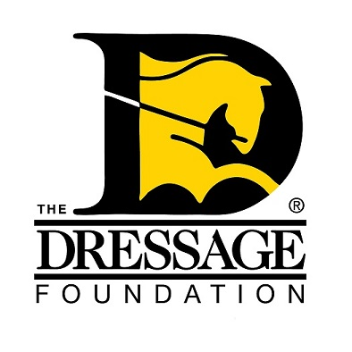
THE DRESSAGE FOUNDATION'S

ODS Linda A. Acheson Fund Grant Application

You can use this form to gather and save your answers, but the online application found on our website must be completed and received by TDF on or before November 15th of each year. Please contact us at (402) 434-8585 or info@dressagefoundation.org if you have questions.

GMO/GMO Chapter Name:
(Preference is given to ODS Chapters)
Contact Person:
Position held in GMO:
Street Address:
City, State, Zip:
Phone:
Email:

Instructional Program

Describe the instructional program to be supported by this application. Is this a camp, clinic, freestyle, seminar, symposium, lecture, etc.? (Preference is given to USDF-approved programs)

What is the daily schedule?

How will this event help the participants?

If applicable, list the level of riders who will be participating in this program (do not include auditors).

Event Details

Date of event:

How many riders will attend?
How many auditors will attend?

Fee per rider:
Fee per auditor:

Location - name of facility, type of facility:

Instructor's name and qualifications

Other Information

How will you advertise this activity?

If your group is awarded a grant from The Dressage Foundation, how will you promote that TDF is a supporter of this program?

Other information regarding your clinic that you think the Selection Committee will find useful in reviewing this application.

Financials

What financial help will your GMO give to this clinic?

Provide a budget of expenses and income.

Amount requested from The Dressage Foundation (Grants will range from $250-$1,000)

Have you registered your event with USDF to earn University Credit? (Required)

IMPORTANT NOTES:
If awarded a grant, it will be used to help the event reach the break-even point and will not be used to make a profit. If the grant is not needed to break even on the event, the remaining funds must be returned to the Fund at TDF. The amount of the grants can vary depending on the need and request of the applicants, but the amount to be awarded will typically range from $250 - $1,000.

The complete application and all required attachments must be submitted through the online application form at www.dressagefoundation.org, on or before November 15th. You will be notified that the application has been received within 2 business days.

If you do not receive email confirmation that your application has been received, please call our office at (402) 434-8585. Additionally, if you have any questions regarding the application, feel free to contact us. Thank you!

