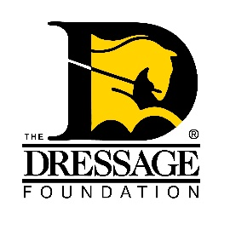
THE DRESSAGE FOUNDATION'S

Dancing Horse Fund Grant Application

You can use this form to gather and save your answers, but the online application found on our website must be completed and received by TDF’s at least 90 days prior to your event for your application to be considered. Please contact us at (402) 434-8585 or info@dressagefoundation.org if you have questions.

Organization Name:
Contact Person:
Position held in Organization:
Street Address:
City, State, Zip:
Phone:
Email:

Instructional Program

Describe your event. Is this a camp, clinic, freestyle, seminar, symposium, lecture, etc.? Include the daily schedule.

What is the need for the program in your area?

How will this program help the participants?

Will you have a demonstration by a freestyle rider in your area? If so, please tell us about the rider.

Will a judge be available to share his/her perspective with participants and auditors? If so, please tell us about the judge.

Event Details

Date of event:

How many riders will attend?
How many auditors will attend?

Fee per rider:
Fee per auditor:

Location - name of facility, type of facility:

Instructor's name and qualifications

What type of sound system will you be using for your event? Has this sound system ever been successfully used for this type of event?

Other Information

How will you advertise this event?

If your group is awarded a grant from The Dressage Foundation, how will you promote that TDF is a supporter of this program?

Other information regarding your clinic that you think the Selection Committee will find useful in reviewing this application.

Financial

Include a budget of expenses and income.

What financial help will your organization give to this program?

Amount requested from The Dressage Foundation? ($300-$750 is the typical amount awarded from the Dancing Horse Fund.)

IMPORTANT NOTES:
The Dressage Foundation's Dancing Horse Fund will grant funding only once in each calendar year to an organization/GMO/facility. The typical range is $300- $750.

The complete application and all required attachments must be submitted through the online application form at www.dressagefoundation.org, at least 90 days prior to the start of the event. You will be notified that the application has been received within 2 business days.

If you do not receive email confirmation that your application has been received, please call our office at (402) 434-8585. Additionally, if you have any questions regarding the application, feel free to contact us. Thank you!

