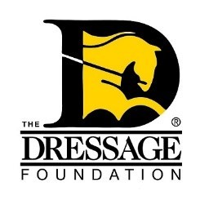
THE DRESSAGE FOUNDATION'S
Dreitzler International Clinican Fund
Grant Application

You can use this form to gather and save your answers, but the online application found on our website must be completed and received by TDF’s office at least 90 days prior to your event for your application to be considered. Please contact us at (402) 434-8585 or info@dressagefoundation.org if you have questions.

Organization/GMO/Facility Name:
Contact Person:
Position held in organization/GMO/Facility:
Street Address:
City, State, Zip:
Phone:
Email:

Instructional Program

Describe your event. Is it a clinic, symposium, seminar, etc? Include the daily schedule?

What is the need for this event in your area?

How will this event help the participants?

If applicable, what level(s) of riders will be participating?

Does your event have a specific educational theme or topic?

Clinician’s name and qualifications

Event Details

Date of event:

How many riders will attend?
How many auditors will attend?

Fee per rider:
Fee per auditor:

Location - name of facility, type of facility:

The success of your program can often be compromised by a poor sound system. What type of sound system will you be using for your event?

Has the sound system been successfully used for this type of program?

Other Information

How will you advertise this activity?

Other information regarding your program that you think the Selection Committee will find useful in reviewing this application.

Financial Information

What financial help will your organization/GMO/facility give to this event?

Include a budget of expenses and income.

Amount requested from The Dressage Foundation?

If your group is awarded a grant from The Dressage Foundation, how will you promote that TDF is a supporter of this program?

IMPORTANT NOTES:
The Dressage Foundation's Dreitzler Fund will grant funding only once in each calendar year to an organization/GMO/facility. The maximum grant is $2,000.
The complete application and all required attachments must be submitted through the online application form at www.dressagefoundation.org, at least 90 days prior to the start of the event. You will be notified that the application has been received within 2 business days.
If you do not receive email confirmation that your application has been received, please call our office at (402) 434-8585. Additionally, if you have any questions regarding the application, feel free to contact us. Thank you!

