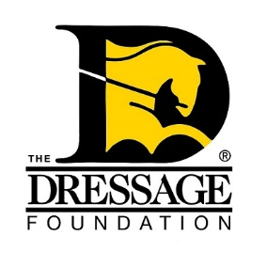
The Dressage Foundation's

Evie Tumlin Memorial Fund

for Region 9 Adult Amateurs
Grant Application

Personal Information:

Name
Address, City, State, Zip
Phone Number
Email Address
Are you a U.S. Citizen or Permanent Resident?

Riding Information:

Are you a member of a USDF Group Member Organization and/or USEA? If yes, which one(s)?

Do you ride dressage, eventing, or both?

Provide a brief summary of your dressage and/or eventing experience for the past few years, including Level(s) ridden, awards received, and educational events attended (max 500 words).

What are your goals as a rider?

Describe volunteer work you have done for the dressage and/or eventing community.

Event/Training Information:

Describe what educational event you plan to attend with this Grant. Include name of program/instructor, date, and location. (The date of the event must take place after April 30th of the year in which you apply.)

What would this Grant allow you to do that you would be unable to do otherwise? Do you have specific goals related to this training?

Financial plan:

Include a line item budget for expenses related to your request.

How much money are you requesting from the Evie Tumlin Memorial Fund? Grant amounts typically range from $500-$1,000.

If you are awarded a partial grant, indicate your plan for paying for the balance of the expenses.
Recommendation Letter:

One recommendation letter is required to be submitted with your application. The letter should speak to your desire to continue your dressage/eventing education, as well as to how you support your dressage/eventing community through volunteer work.

APPLICATIONS MUST BE RECEIVED THROUGH THE ONLINE FORM ON OR BEFORE MARCH 1st IN ORDER TO BE CONSIDERED.
www.dressagefoundation.org

