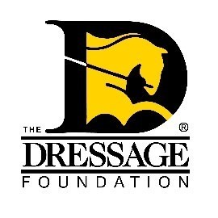
The Dressage Foundation’s
Lynn Palm Western Dressage Fund
Grant Application for Individuals

You can use this form to gather and save your answers, but the online application found on our website must be completed and received by TDF’s office on or before July 20th for your application to be considered. Please contact us at (402) 434-8585 or info@dressagefoundation.org if you have questions.

Contact Information

Name:
Address:
Phone:
Email:
Are you a U.S. Citizen or Permanent Resident?
WDAA Membership Number and # of years you’ve been a member:
USEF Membership Number and # of years you’ve been a member:
Are you applying as a:
___ Youth ___ Adult Amateur ___Professional
If under 19 years of age, please provide the name, address, and email of your parent/guardian.

Riding Information:

How long have you been riding Western Dressage? How did you get started?
If you have not yet started in the discipline, why do you want to?

Provide a brief summary of your dressage training and showing experience for the past 5 years.
- Include levels ridden and awards received.
- How have you continued your Western Dressage education? (clinics, lessons, studies, etc) Please include who you have trained with.

If applying as a professional:
- How long have you been a Western Dressage professional? Are you an instructor, trainer, judge, and/or clinician?
- Tell us about your business – include number of students, their average age, skill level, number of horses in training, schedule as a clinician, etc.

What are your goals for the next 12 months?

What are your long-term “dream” goals?

In what ways have you been involved in your Western Dressage community on a local, regional, and/or national level? Examples include hosting open clinics, donating time/resources, volunteer work, etc.

Event/Training Information:

Describe what educational event(s) and/or training you plan to participate in with this Grant. Include name of instructor with a short bio, dates, location.

What specific goals do you wish to achieve during this time?

What will be different from what you normally do in your regular training? What would this Grant allow you to do that you would be unable to do otherwise?

Financial:

Grants are currently $1,000 each. Provide a detailed budget of how you plan to use the grant funds. If the grant doesn’t cover all expenses, please indicate to the Committee how you will handle the balance of these expenses.

Financially speaking, why do you need this grant for your Western Dressage training?

Video:
Please submit a YouTube link of a recent 4–5-minute riding video. The video can be schooling or at a show.

Recommendation Letters:

Provide one recommendation letter from someone who can speak to your dedication to Western Dressage, your desire to improve, and your volunteer activity.

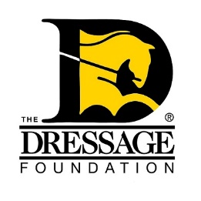
The Dressage Foundation’s
Lynn Palm Western Dressage Fund for Individuals
Required Signatures/Acknowledgement
The undersigned applicant hereby represents and acknowledges that:
- The information contained in this application is accurate and complete to the best of my knowledge.
- I am aware that if I am selected, funds must be used within one year of the award announcement.
- I will receive 75% of the grant amount prior to the working with a professional to create a freestyle, as stated in the attached application. The final 25% will be sent once The Dressage Foundation (TDF) has received the required report and financial summary.
- If I am chosen as a recipient for the Lynn Palm Western Dressage Fund Grant, I will meet the requirement to provide a report, and financial summary to TDF within two months following the completion of my training.
- TDF has permission to use my report, in whole or in part, in online and written publications.
- If there is a change to any part of the plan included in this application TDF must be notified prior to the use of the grant funds.
- TDF reserves the right to not award the grant or modify the amount of funding if the training plan presented in this application changes for any reason.
- I agree to return any paid money to TDF if it cannot be used for its intended purpose as presented in the grant application.
If an individual applicant is awarded a grant from The Dressage Foundation, it is acknowledged that TDF will require a photograph of applicant for use in news releases, on the TDF website, in brochures and newsletters, or in other mediums at TDF’s discretion. The applicant hereby grants TDF an irrevocable license to publish, reproduce, broadcast, transmit, or otherwise use any photograph(s) provided by applicant in the ways stated above. The applicant hereby releases TDF, its employees, directors, and agents from any liability connected with the publication, reproduction, release, or other use of the applicant’s photograph, and agree not to bring any claims against them growing out of such uses by TDF.

I also attest that I am a Citizen or Permanent Resident of the United States.

Signature of Applicant Date

Applicant Name – Printed

