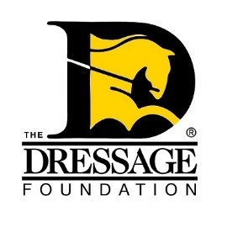
Karen Skvarla Fund
For Young Dressage Professionals
Grant Application

You can use this form to gather and save your answers, but the online application found on our website must be completed and received by TDF’s office on or before February 15th for your application to be considered. Please contact us at (402) 434-8585 or info@dressagefoundation.org if you have questions.

Contact Information:

Name:
Address:
City:
State, Zip:
Phone:
Email:
Current Age:
Are you a U.S. Citizen or Permanent Resident? Yes/No
Please list equestrian organizations in which you are a member (including local clubs).

What amount are you requesting from the Karen Skvarla Fund (Grants range from $1,000-$1,500)?

Proposed Training Plan (in one sentence):

You will provide additional details below.

Proposed Training Dates:

Professional Information:

- Are you currently a dressage instructor/trainer? If yes, is this at your own barn? If no, are you employed by an equestrian center? Name the equestrian center if employed by them.

- How long have you been a dressage professional?

- How many students do you have?

- What is the average age and skill level of your students and/or horses you train?

- How much time do you devote to teaching and/or training?

- Are you presently competing? If so, at what level/s?

- Provide a brief summary of your dressage experience for the past 2 years, including level(s) ridden, awards received, and educational activities that improved your abilities as an instructor/trainer.

- Provide examples of your equestrian-related community service.

Your Training Plan:

- Tell us about the event you’d like to attend and/or the instructor you’d like to work with.

- What are your expectations for working with your trainer or attending this educational event? What are some definite areas of accomplishment that you wish to achieve? Please present a clear training plan and goals.

- Tell us why you should be selected for a Karen Skvarla Fund Grant.

Financial Planning Information:

- Provide a detailed budget for your training plan.
- We do not anticipate that the Grant will cover all expenses incurred. Please indicate to the Committee how you will handle the balance of these expenses.

Reference Letters:

Provide two (2) reference letters - one personal letter of recommendation and one dressage/horse industry letter of recommendation. The personal letter of recommendation should not come from a family member.

APPLICATIONS MUST BE COMPLETED THROUGH THE ONLINE FORM ON OR BEFORE FEBRUARY 15TH IN ORDER TO BE CONSIDERED.

