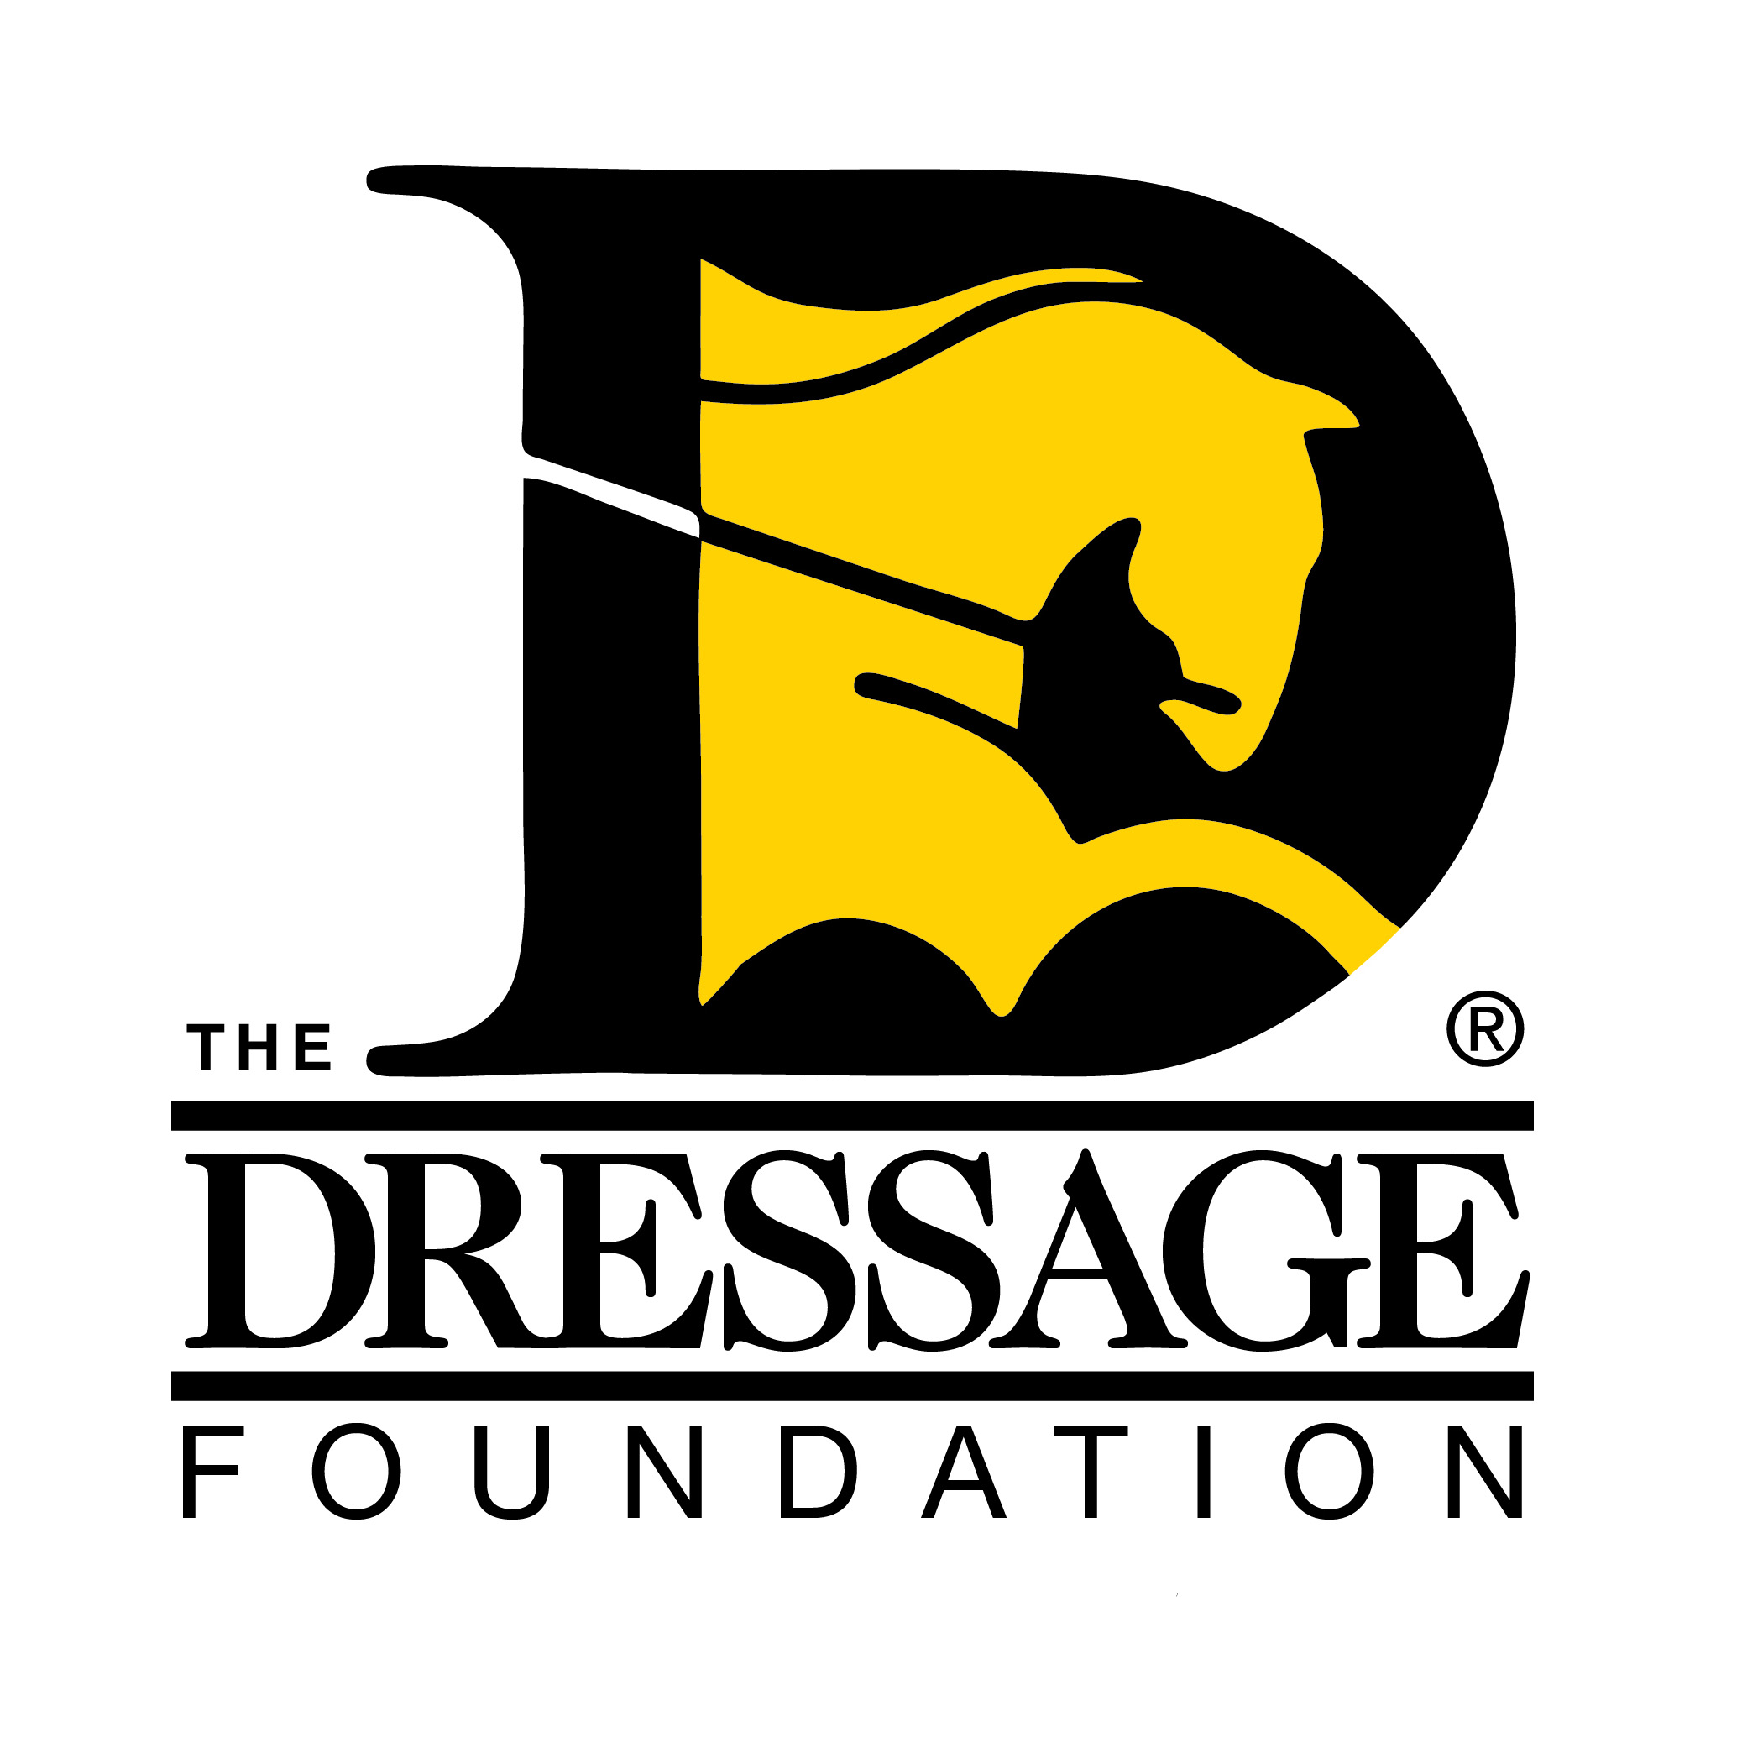
The Dressage Foundation’s
Century Club Application
Please return completed applications at least two weeks prior to the date of the scheduled ride to ensure your ribbon arrives in time.

Name:
Street Address:
City: State ________ Zip
Phone number:
Email address:
Your date of birth: _____/_____ /______ Age at time of ride: _ ____________
Horse’s name:

Do you have a preferred name for yourself and/or your horse for the
Publications (newspaper, magazine, etc.): _________________________________
Or Plaque: ___________________________________________________________
(If unanswered the name on the plaque will match the horse’s registered name)
Horse’s date of birth: / / Age of horse: ___________________
(Horse attains another year of age on each January 1st, no matter when foaled)

Breed:
Are you a member of a Dressage Club? ___ If so, please list the Organization/s:
1)
2)
What is the anticipated date of your Century Club Ride?

Where do you plan to ride for your Century Club Membership (Show Name, Location)?
(Over)

Show Manager’s Name: ____________________________________________________________ _____

Show Manager’s Email: __________________________________________________________
Do you have a primary contact person other than yourself? If so, what is his/her name and email?
The Dressage Foundation may wish to send out a press release in your area. What is
the name of your local newspaper?

How did you hear about the Century Club? _______________________________

Please mail or email this application to: The Dressage Foundation
1314 'O' Street, Suite 305
Lincoln, NE 68508

Email: sara@dressagefoundation.org

Questions? Call Sara Weiss, Director of Grants and Programs at (402) 434-8585

Please check this box if you would like to help promote TDF and the Century Club! We will send you flyers to pass out at your show along with your ribbon.

